**SOURCE CODE & OUTPUT:**

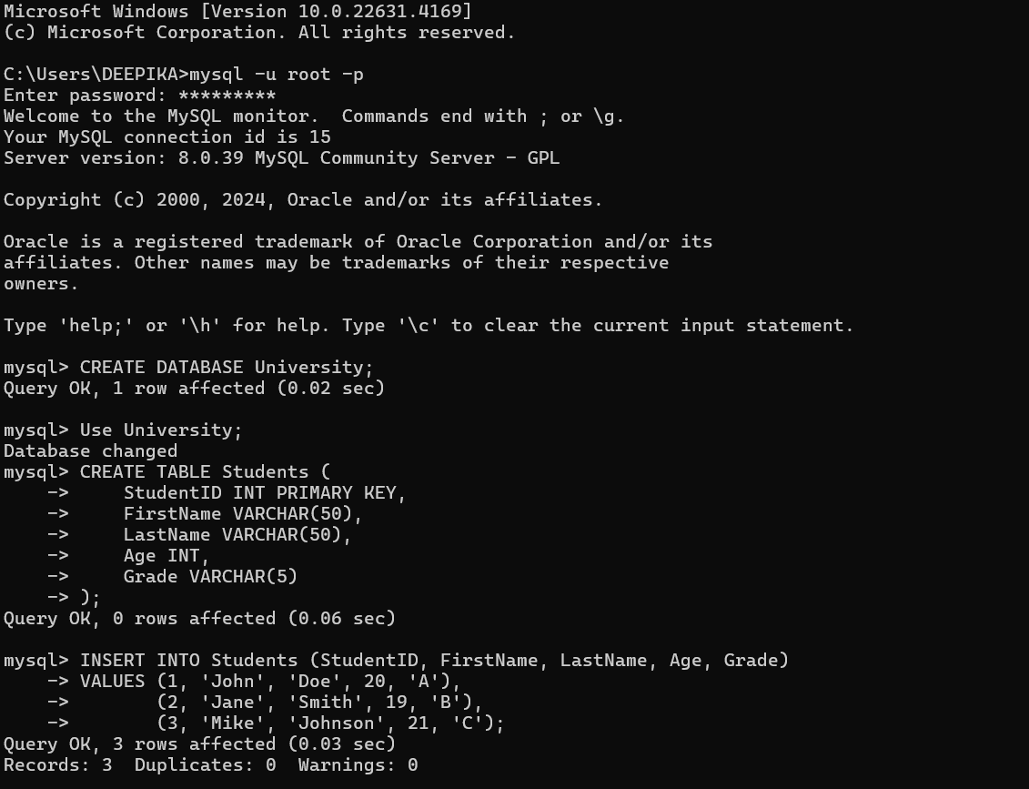

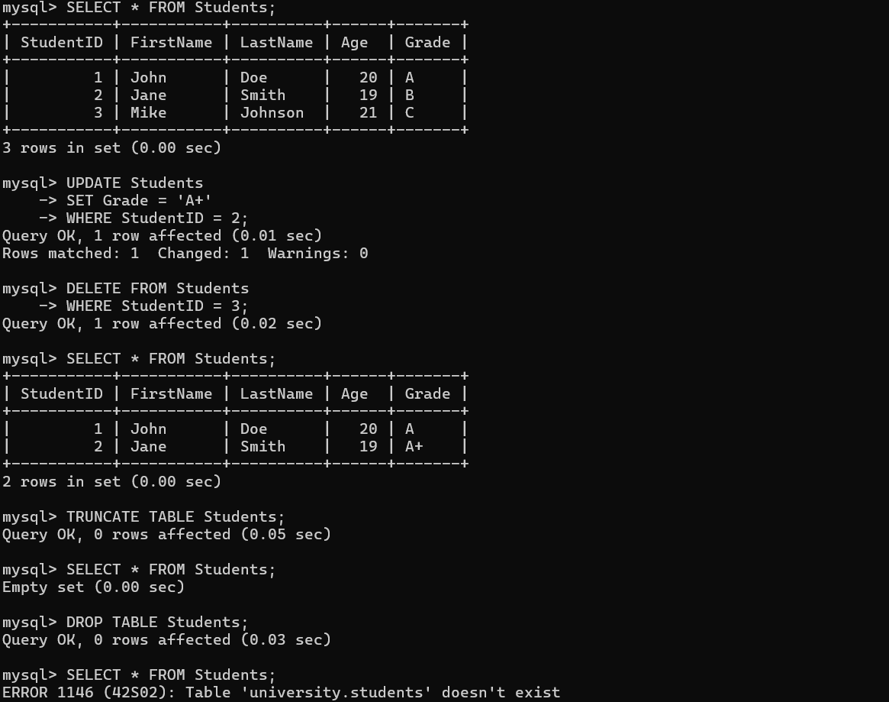

**SOURCE CODE & OUTPUT:**

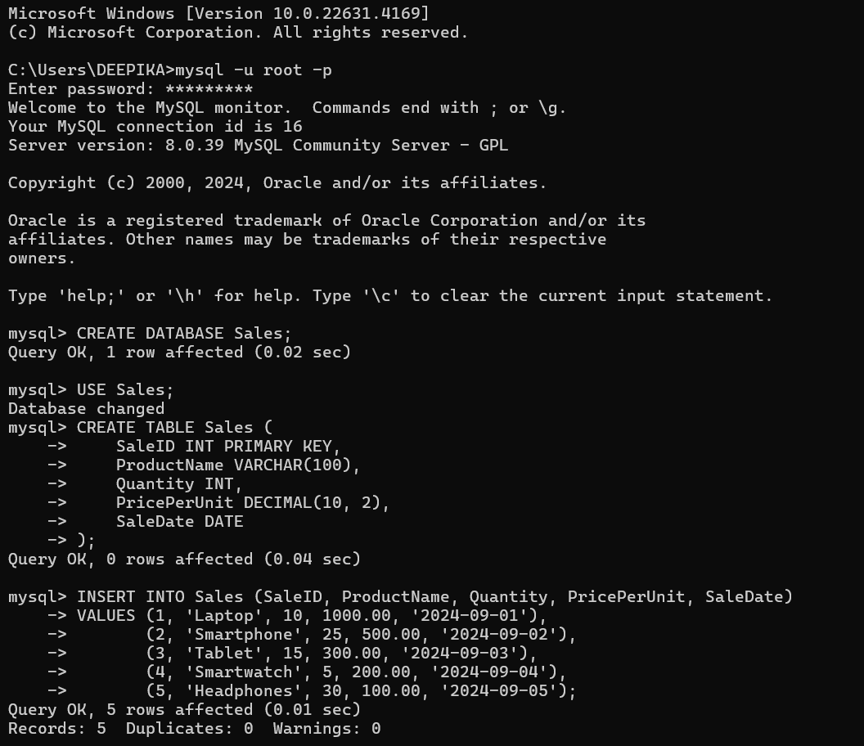

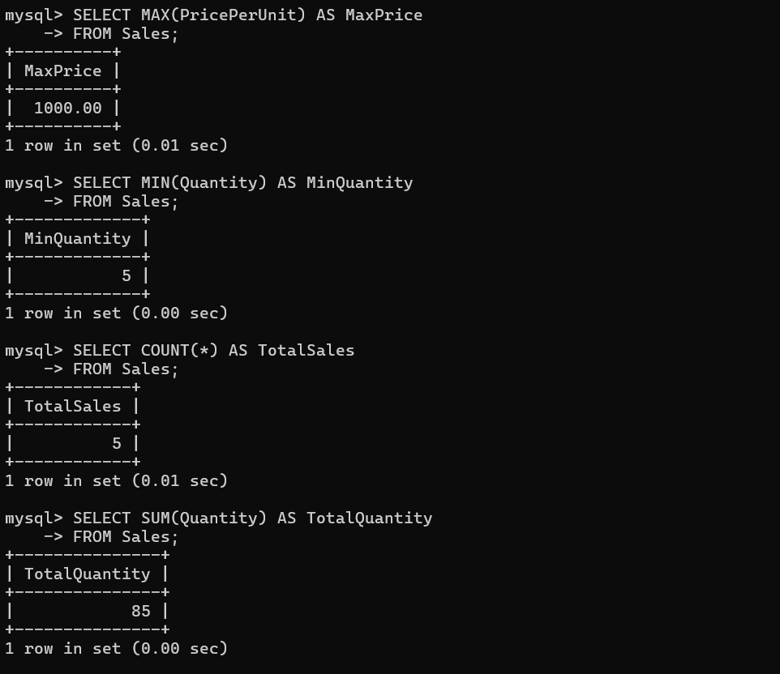

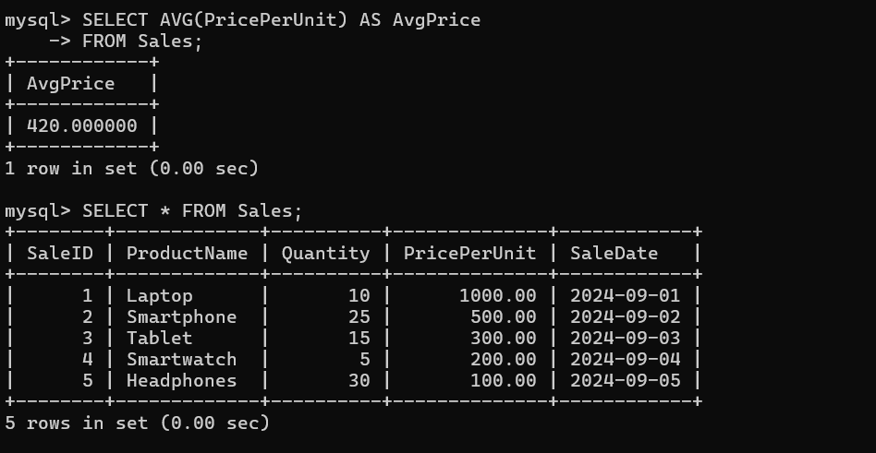

**SOURCE CODE & OUTPUT:**

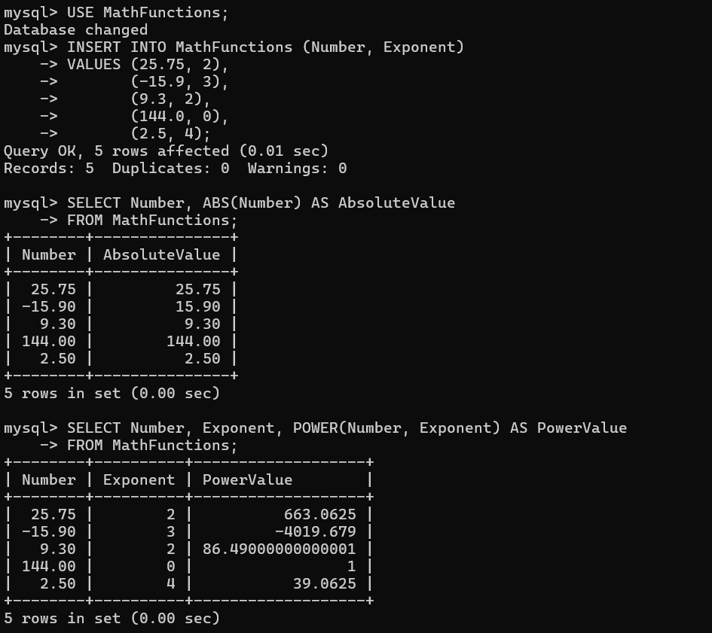

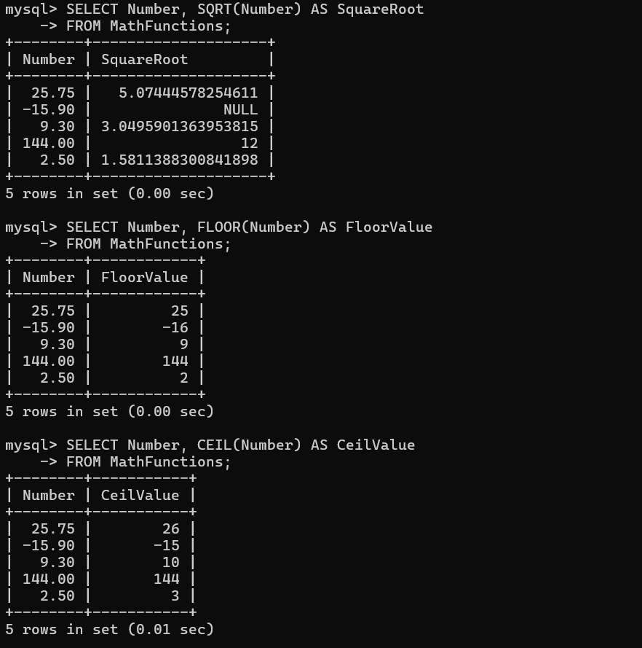

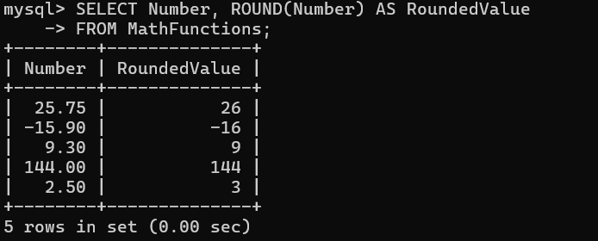

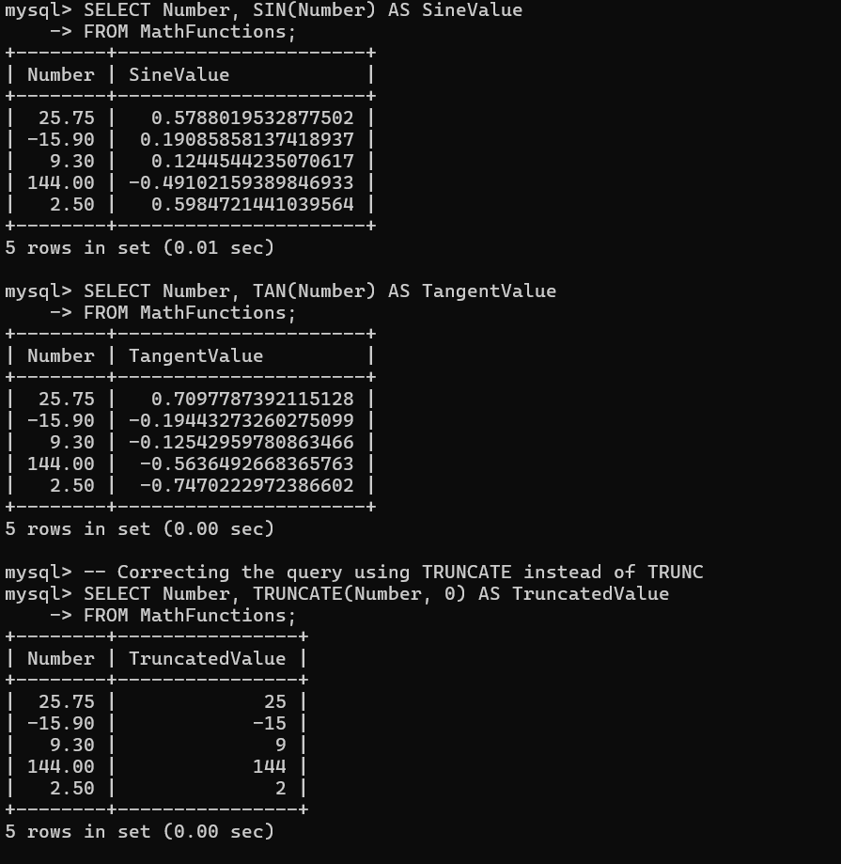

**SOURCE CODE & OUTPUT:**

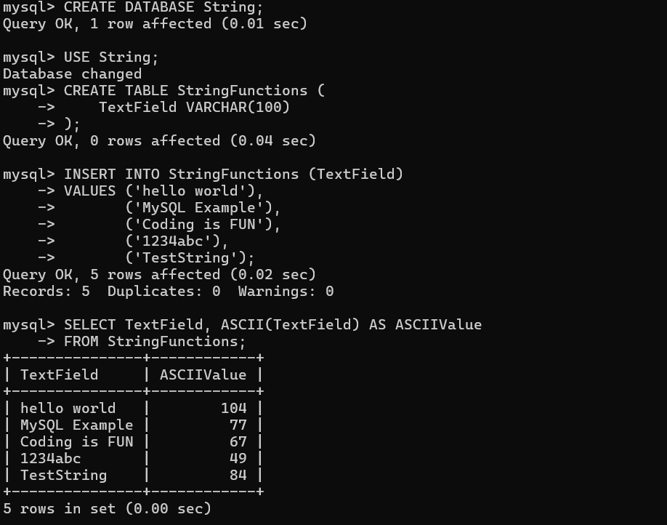

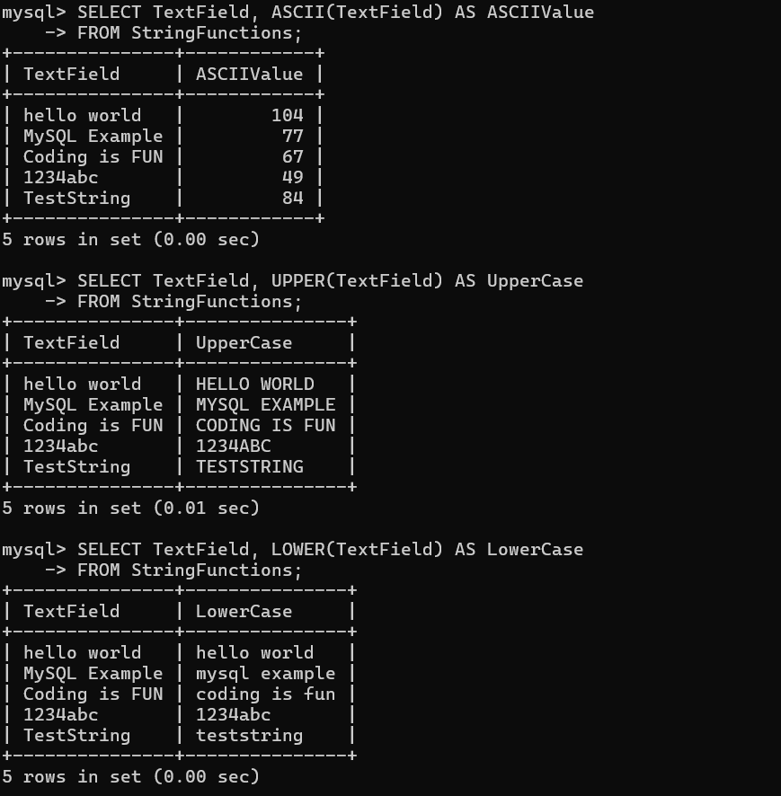

**SOURCE CODE & OUTPUT:**

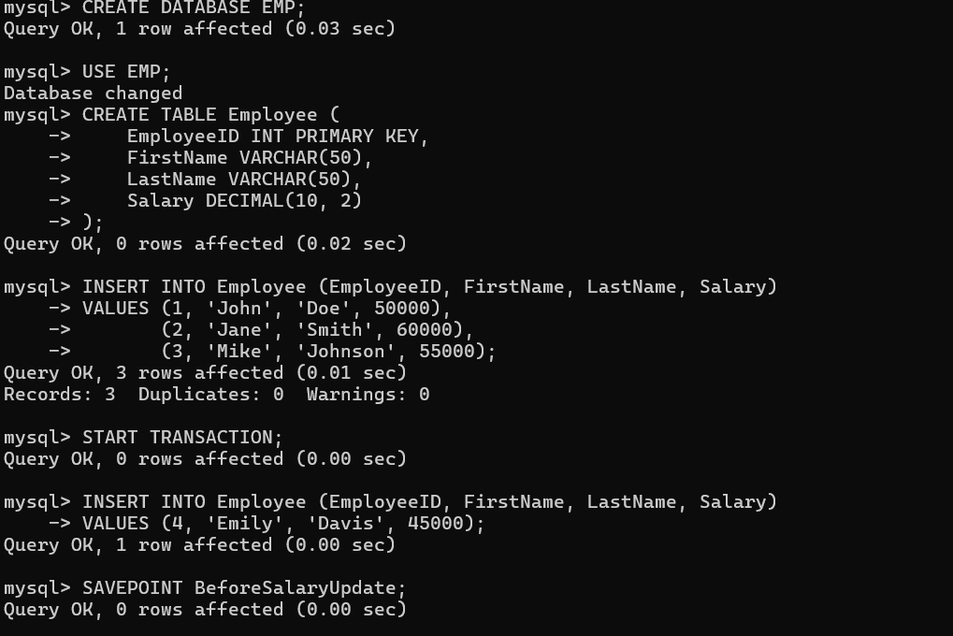

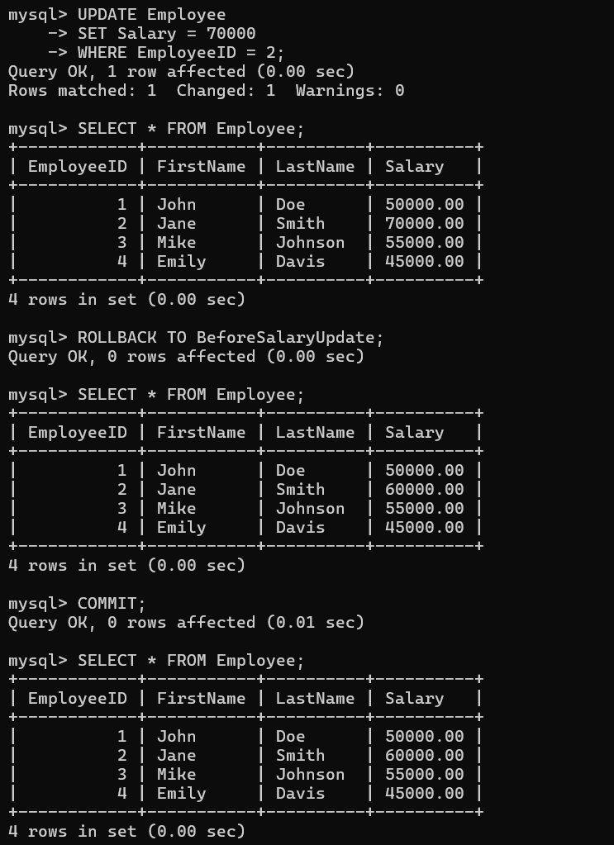

**SOURCE CODE & OUTPUT:**

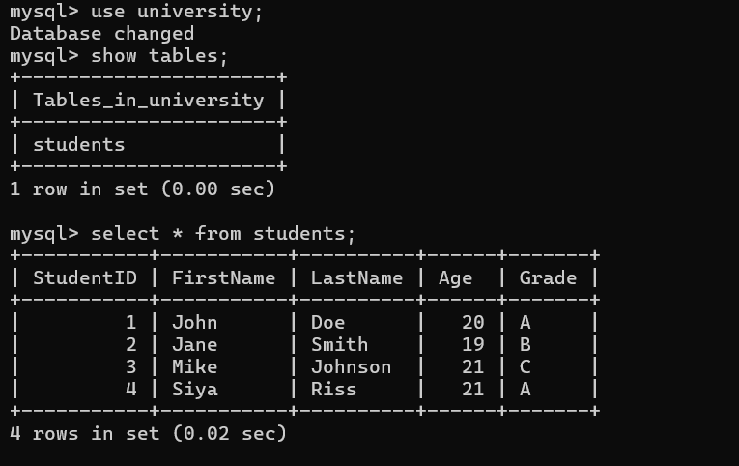

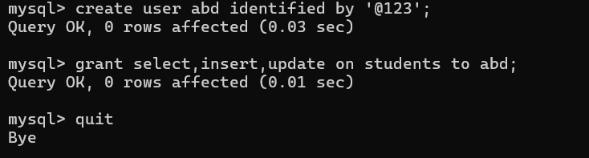

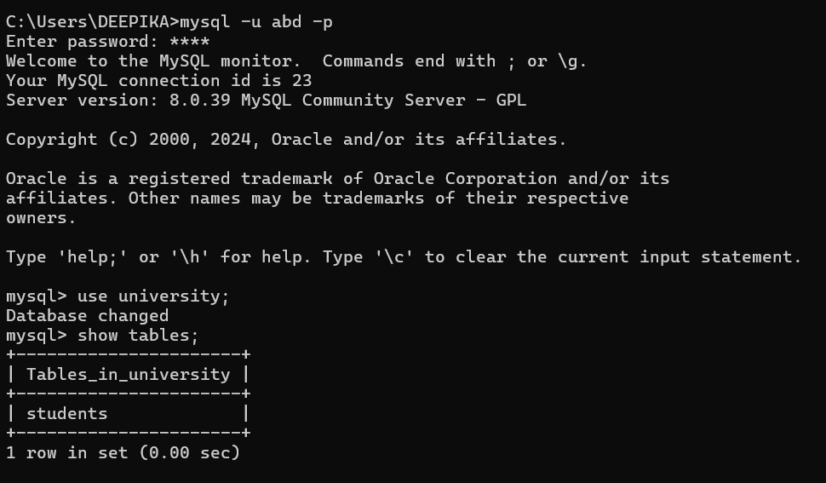

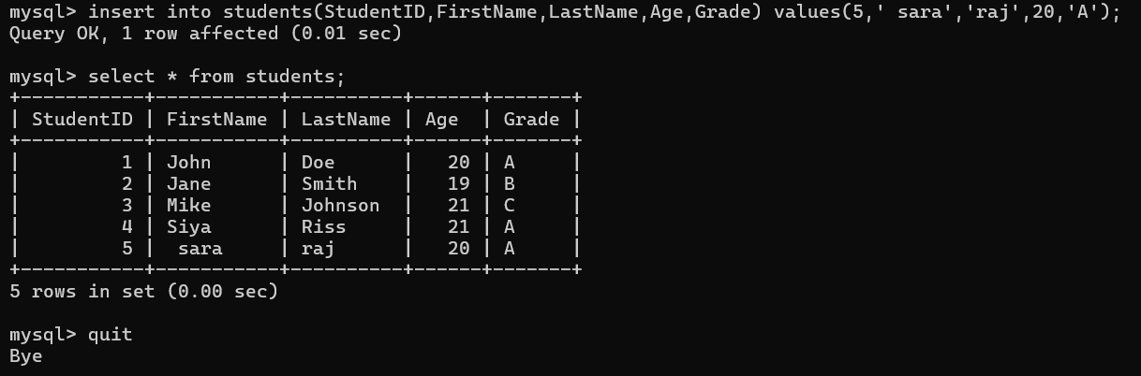

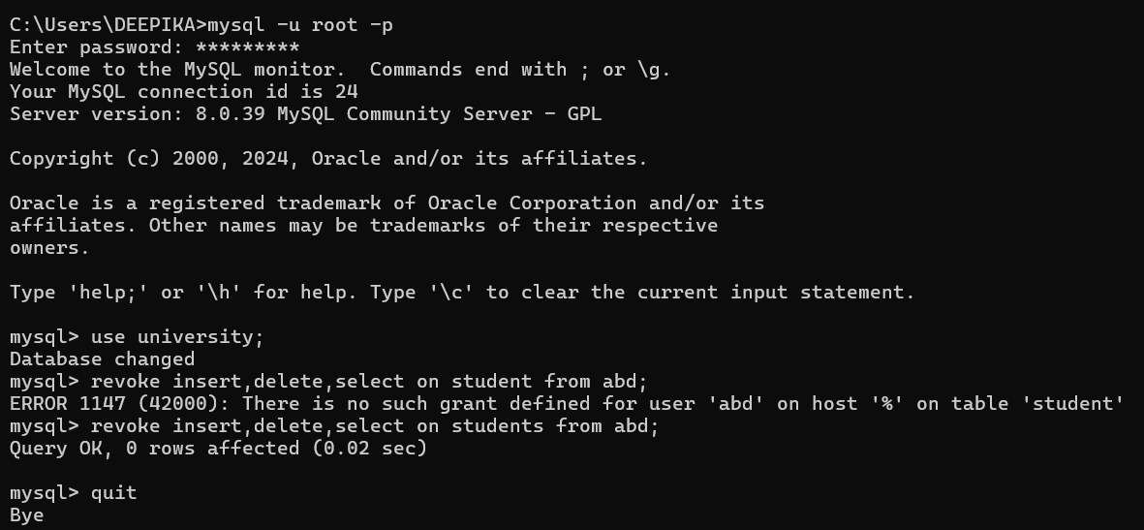

**SOURCE CODE & OUTPUT:**

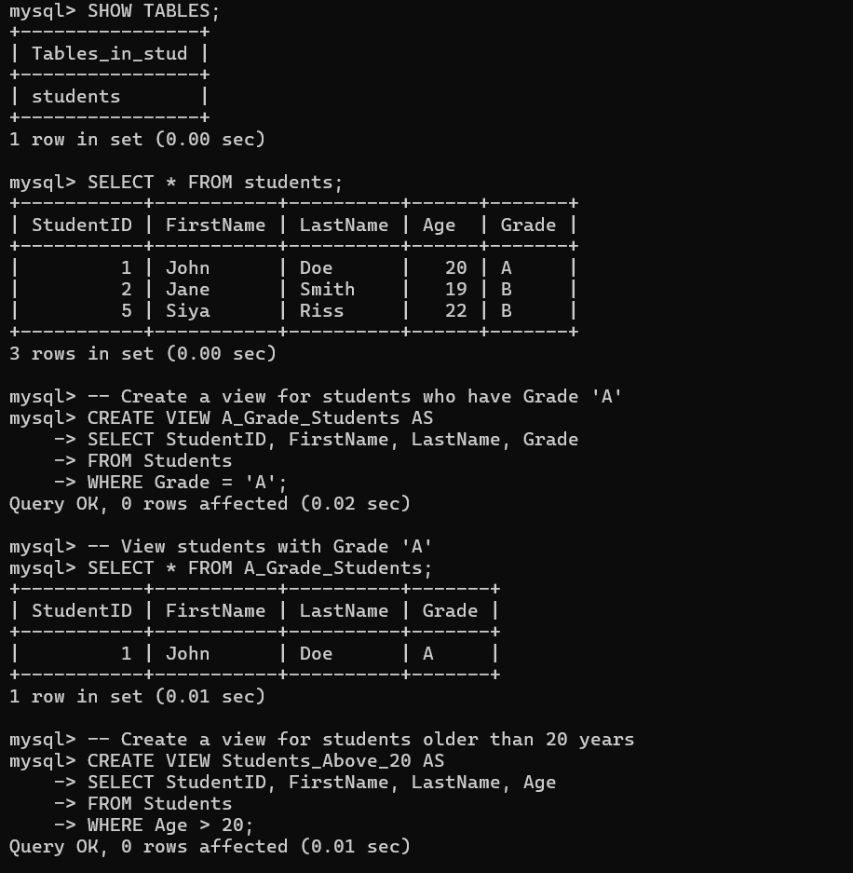

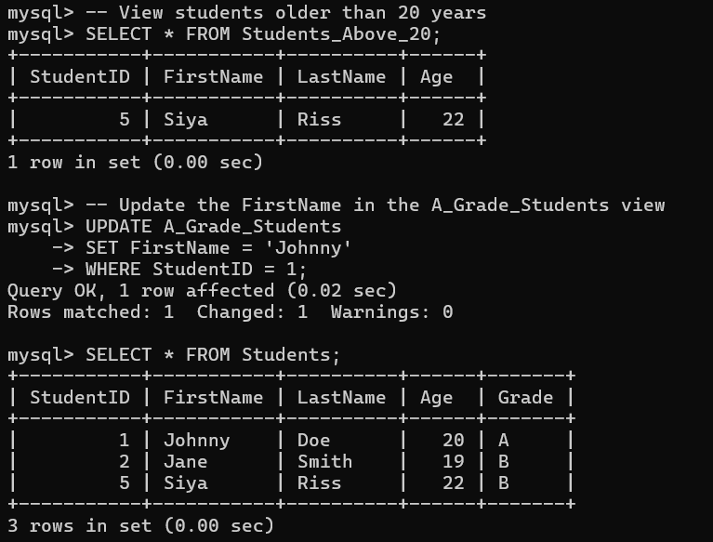

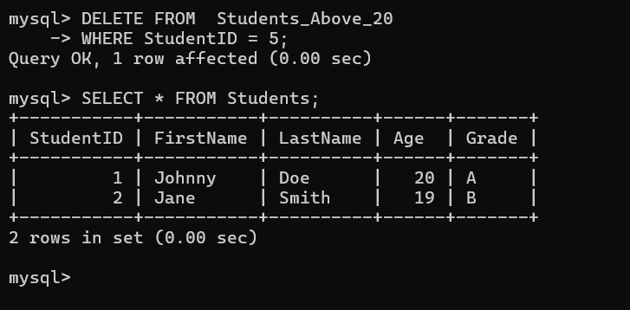

**SOURCE CODE & OUTPUT:**

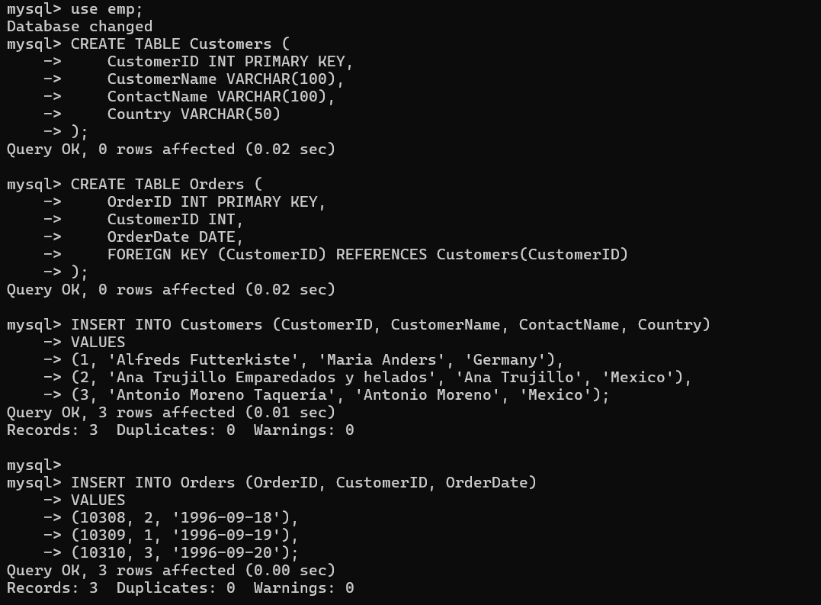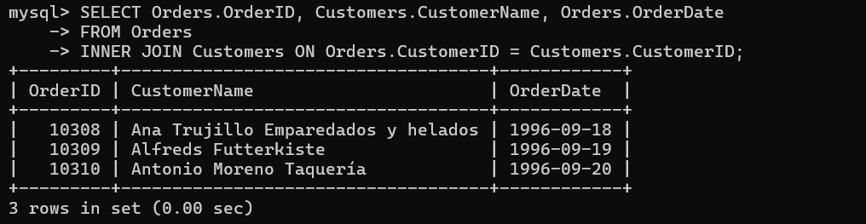

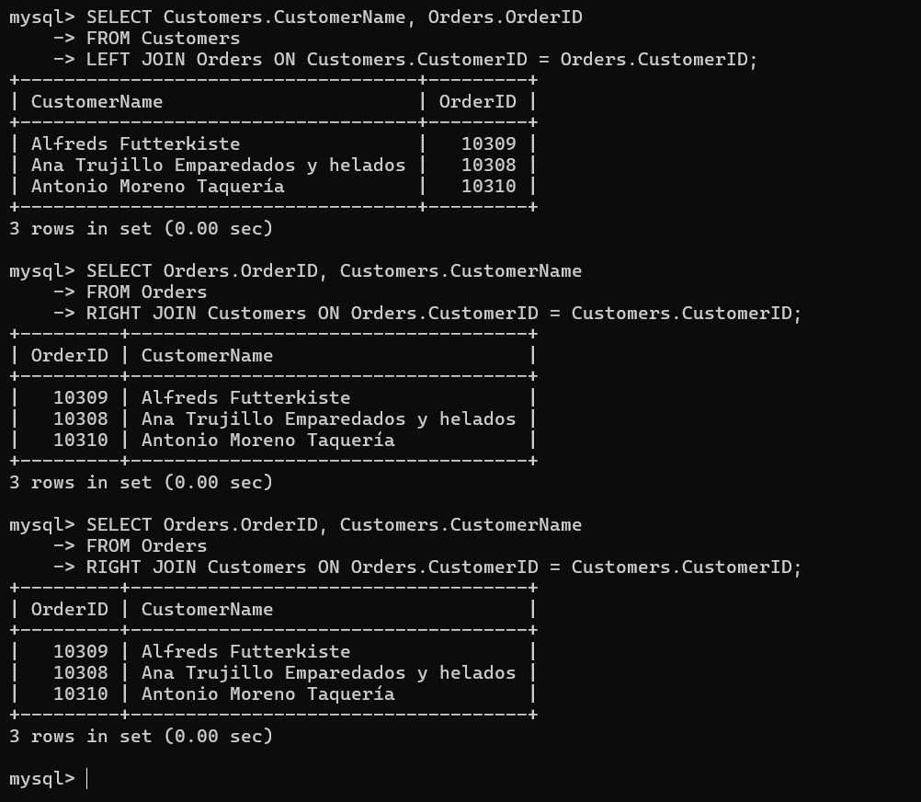

**SOURCE CODE & OUTPUT:**

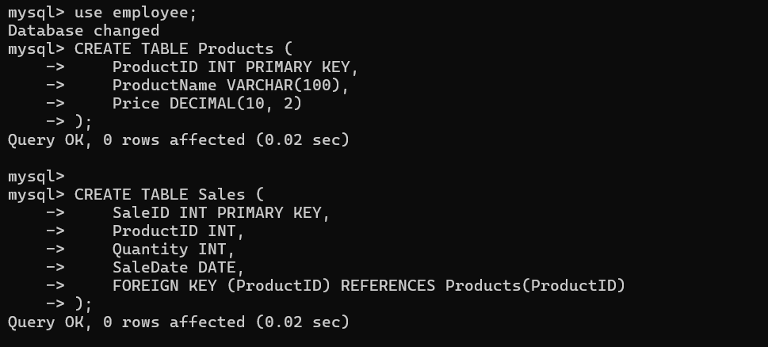

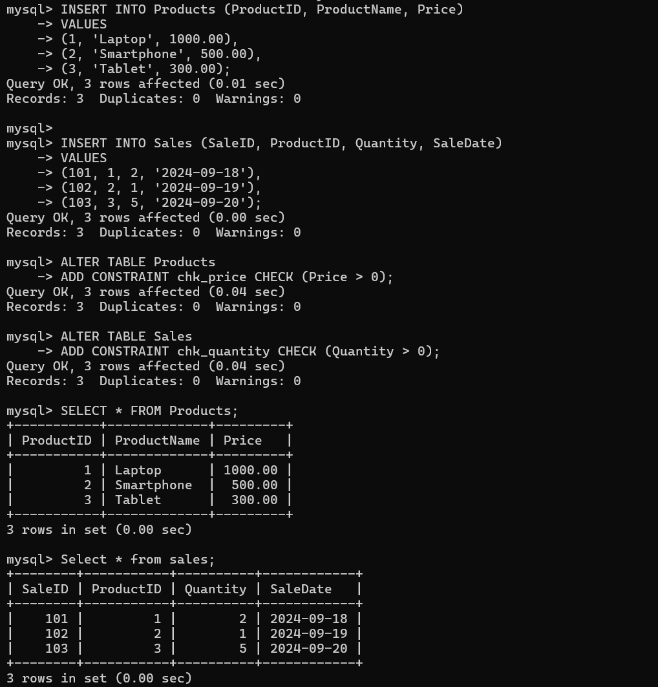

**SOURCE CODE & OUTPUT:**

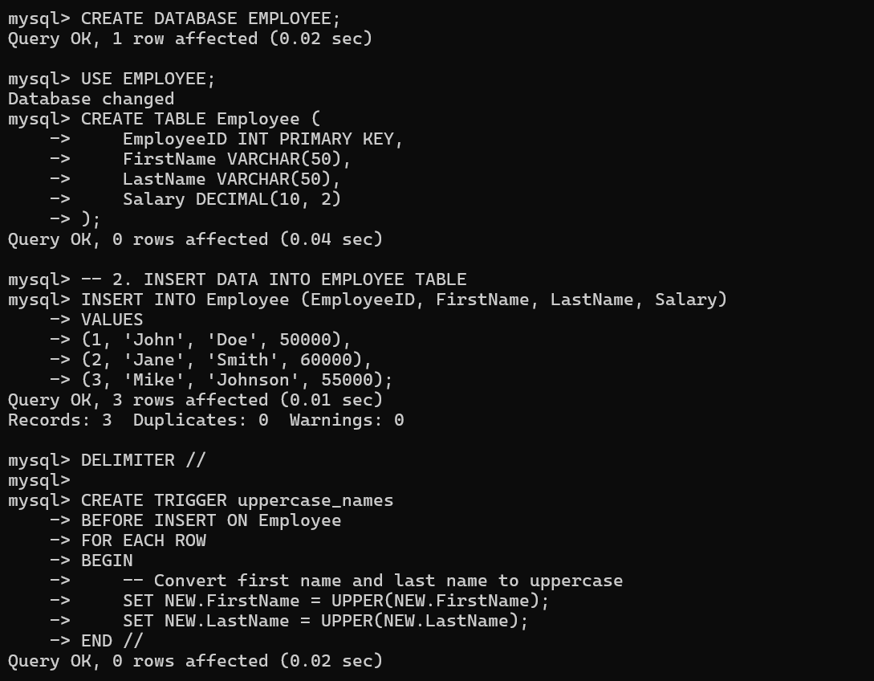

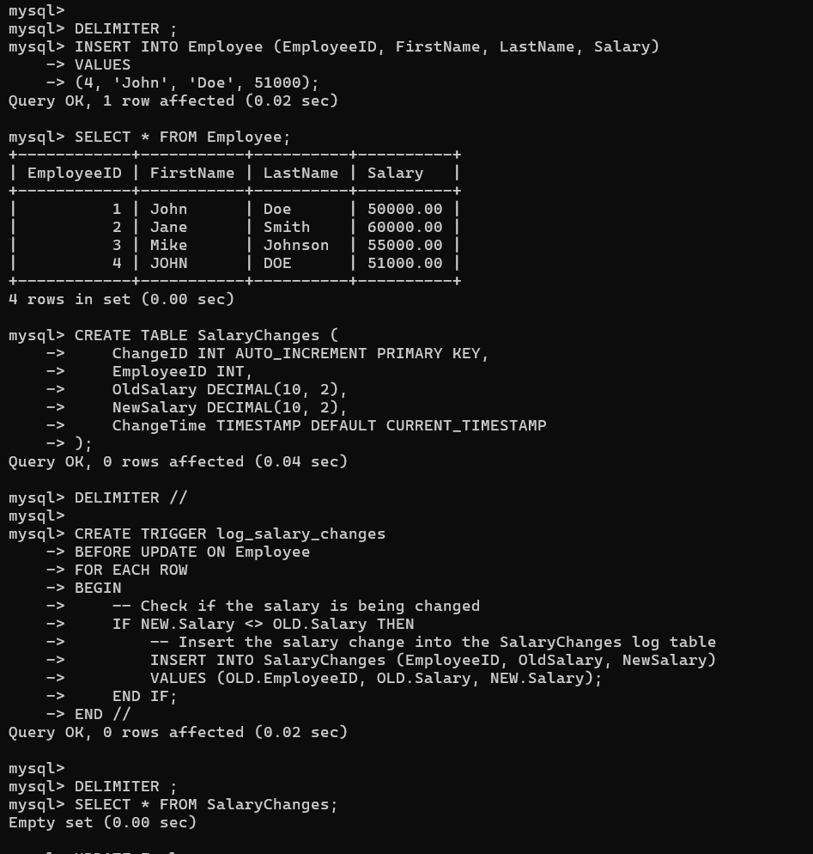



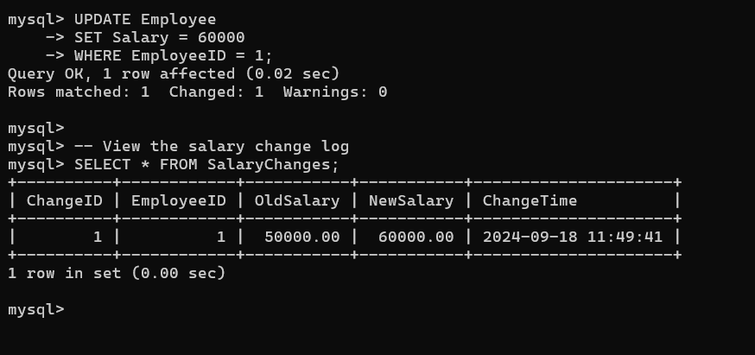

**SOURCE CODE:**DECLARE

total_rows NUMBER(2);

BEGIN

UPDATE customers

SET salary = salary + 500;

IF SQL%NOTFOUND THEN

DBMS_OUTPUT.PUT_LINE('No customers updated');

ELSE

total_rows := SQL%ROWCOUNT;

DBMS_OUTPUT.PUT_LINE(total_rows || ' customers updated.');

END IF;

END;

/

**OUTPUT:**

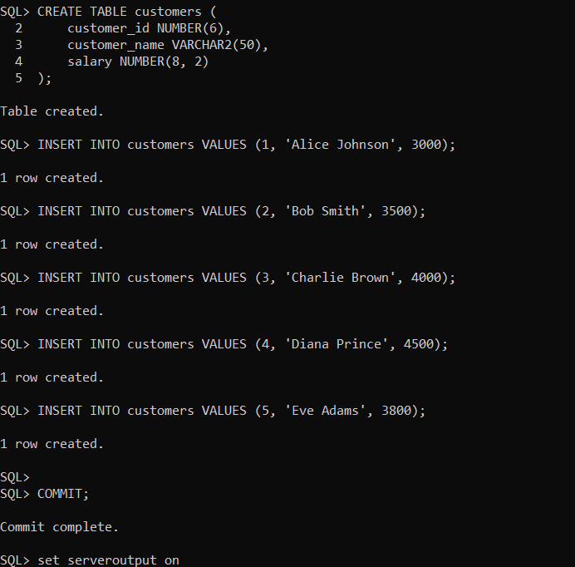

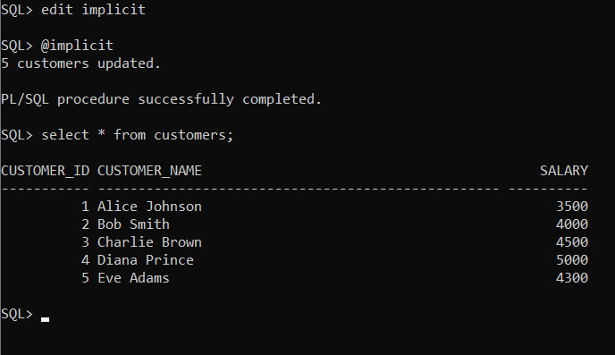

**SOURCE CODE;**

DECLARE

CURSOR c_customer IS

SELECT name, address FROM customer;

v_name customer.name%TYPE;

v_address customer.address%TYPE;

BEGIN

OPEN c_customer;

LOOP

FETCH c_customer INTO v_name, v_address;

EXIT WHEN c_customer%NOTFOUND;

DBMS_OUTPUT.PUT_LINE('Name: ' || v_name);

DBMS_OUTPUT.PUT_LINE('Address: ' || v_address);

END LOOP;

CLOSE c_customer;

END;

/

**OUTPUT:**

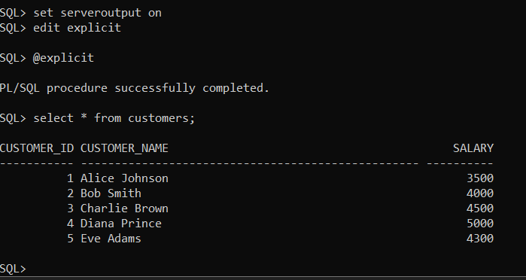

**SOURCE CODE:**

DECLARE

v_customer_name CUSTOMERS.CUSTOMER_NAME%TYPE;

BEGIN

SELECT CUSTOMER_NAME

INTO v_customer_name

FROM CUSTOMERS

WHERE CUSTOMER_ID = 101; -- Assumed ID for demonstration

DBMS_OUTPUT.PUT_LINE('Customer Name: ' || v_customer_name);

EXCEPTION

WHEN NO_DATA_FOUND THEN

DBMS_OUTPUT.PUT_LINE('Error: No customer found with the given ID.');

WHEN TOO_MANY_ROWS THEN

DBMS_OUTPUT.PUT_LINE('Error: More than one customer found with the given ID.');

WHEN OTHERS THEN

DBMS_OUTPUT.PUT_LINE('An unexpected error occurred: ' || SQLERRM);

END;

/

**OUTPUT:**

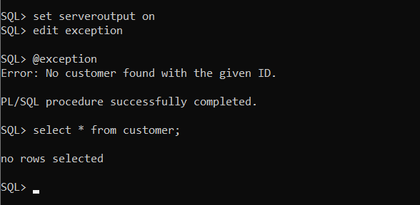

**SOURCE CODE:**

DECLARE

c_id clients.id%TYPE := &cc_id;

c_name clients.name%TYPE;

c_addr clients.address%TYPE;

ex_invalid_id EXCEPTION;

BEGIN

IF c_id <= 0 THEN

RAISE ex_invalid_id;

ELSE

SELECT name, address

INTO c_name, c_addr

FROM clients

WHERE id = c_id;

DBMS_OUTPUT.PUT_LINE('Name: ' || c_name);

DBMS_OUTPUT.PUT_LINE('Address: ' || c_addr);

END IF;

EXCEPTION

WHEN ex_invalid_id THEN

DBMS_OUTPUT.PUT_LINE('ID must be greater than zero!');

ID

WHEN NO_DATA_FOUND THEN

DBMS_OUTPUT.PUT_LINE('No such client!');

WHEN OTHERS THEN

DBMS_OUTPUT.PUT_LINE('Error: ' || SQLERRM);

END;

/

**OUTPUT:**

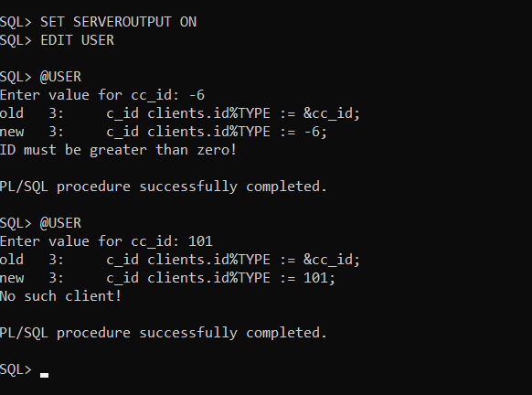

**SOURCE CODE:**

CREATE TABLE sum_results (

id NUMBER GENERATED BY DEFAULT AS IDENTITY PRIMARY KEY,

num1 NUMBER,

num2 NUMBER,

result NUMBER

);

CREATE OR REPLACE FUNCTION calculate_sum(a IN NUMBER, b IN NUMBER) RETURN NUMBER IS

c NUMBER;

BEGIN

c := a + b;

INSERT INTO sum_results (num1, num2, result) VALUES (a, b, c);

RETURN c;

END calculate_sum;

/

**OUTPUT:**

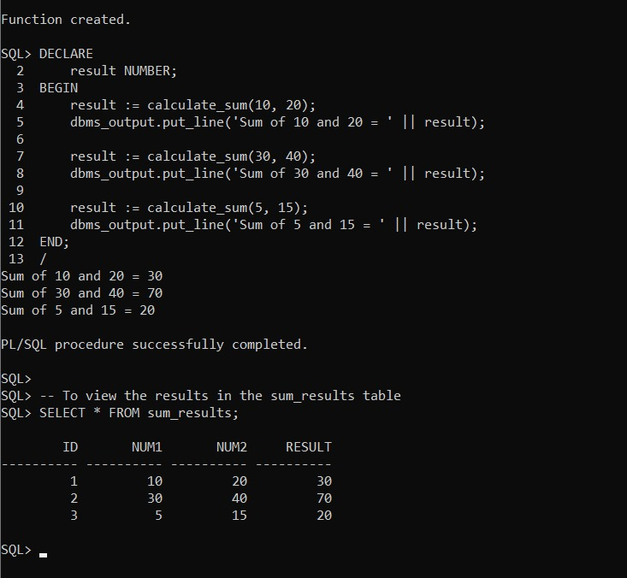

**SOURCE CODE:**

CREATE OR REPLACE PROCEDURE calculate_sum_proc(a IN NUMBER, b IN NUMBER) IS

c NUMBER;

BEGIN

c := a + b;

INSERT INTO sum_results (num1, num2, result) VALUES (a, b, c);

DBMS_OUTPUT.PUT_LINE('The sum of ' || a || ' and ' || b || ' is: ' || c);

END calculate_sum_proc;

/

**OUTPUT:**

